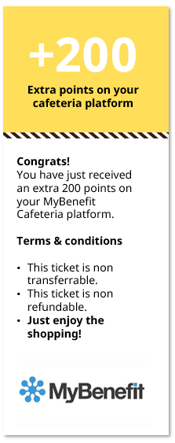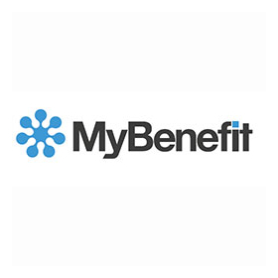

As Ingvar said *„(…) No one can be happy or do a good job unless they like the place where they work. After all, it’s there that they spend most of their waking hours.* ***Feeling appreciated and motivated leads to good results.”***

We'd like to thank you for your great support in past months. We appreciate your engagement in POT project as well as your willingness and openness to take a new roles & responsibilities as Knowledge specialist and Beta's coordinator. We value your responsible way of working and team player skills. You are a great contributor to our team. Keep up the good job!

**YOU’RE THE BEST!**

This is the big thank you to:

**Jan Kowalski**

**Katarzyna Koźlicka**

PA/PY Deputy Team Leader

**Agata Bajsztok**

PA/PY Team Leader

**Agnieszka Choodowska**

PA/PY Team Leader

**María Belén Toro Mallero**

PA/PY Services Manager

**Congrats!**

You have just received an extra 200 points on your MyBenefit Cafeteria platform.

**Terms & conditions**

* This ticket is non transferrable.
* This ticket is non refundable.
* **Just enjoy the shopping!**

**+200**

**Extra points on your cafeteria platform**

SSC Poznan